CIRCUIT ANALYSIS LAB_3
Name: Muhammad Uzair
Reg No: 2025-CE-112
Date: 22ndMarch,2026

Experiment # 1: Measure Current between R1 and R2, and Voltage across R1, R2.
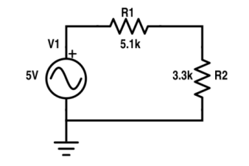

TABLE FOR READINGS:
Practical Values:
R₁ Voltage | R₂ Voltage | Current between R₁ & R₂
2.14V | 1.39V | 0.42mA

Theoretical Values:
R₁ Voltage | R₂ Voltage | Current between R₁ & R₂
2.14V | 1.39V | 0.42mA

Experiment # 2: Measure Current at node 2 and 3 and Voltage across R1, R2, R3.

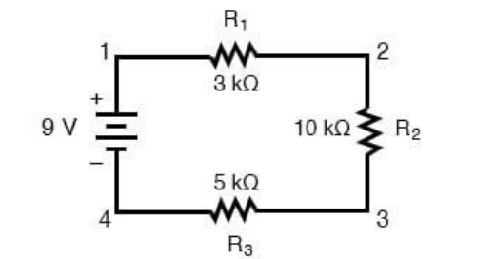

TABLE FOR READINGS:

Practical Values:
R₁ Voltage | R₂ Voltage | R₃ Voltage | Current at Node 2 | Current at Node 3
1.5V | 5V | 2.5V | 0.5mA | 0.5mA

Theoretical Values:
R₁ Voltage | R₂ Voltage | R₃ Voltage | Current at Node 2 | Current at Node 3
1.5V | 5V | 2.5V | 0.5mA | 0.5mA
POST LAB QUESTIONS & ANSWERS:
1. Define energy.
Energy is the capacity to do work or produce change in a system. It can exist in various forms such as electrical, mechanical, thermal, or chemical.
2. Define power.
Power is the rate at which energy is transferred or converted per unit time. Its SI unit is the watt (W).
3. What is charge?
Charge is a fundamental property of matter that causes it to experience a force in an electric field. The unit of charge is the coulomb (C).
4. What is circuit?
A circuit is a closed path through which electric current can flow. It consists of a source, conductors, and load components.
5. What is the role of a resistor in the series circuit?
A resistor limits or controls the current flowing through the circuit. It divides voltage among other resistors and protects components from excessive current.
6. What is the voltage divider rule?
The voltage divider rule states that in a series circuit, the voltage across a resistor is proportional to its resistance and the total applied voltage.
V_{R}= (R/R_{Total})*V_{Total}
7. What are the features of the series circuit?
- Current is the same through all components.
- Total resistance is the sum of individual resistances.
- Voltage divides among components.
- If one component fails, the whole circuit stops.
8. Differentiate between the internal circuit of voltmeter and ammeter.
- A voltmeter has a very high internal resistance to minimize current draw from the circuit.
- An ammeter has a very low internal resistance to allow current to pass easily.
- Voltmeters are connected in parallel; ammeters in series.
- Voltmeters measure voltage across components; ammeters measure current through components.
- Voltmeters prevent circuit loading; ammeters prevent voltage drop.
- Internal design ensures measurement accuracy without affecting the main circuit.

9. In which combination we connect DMM to measure current and voltages.
- To measure current, connect the DMM in series with the component.
- To measure voltage, connect the DMM in parallel across the component.

